Linux Basics Assignment
1. Creating and Renaming Files/Directories
Create a directory named test_dir using mkdir.
Inside test_dir, create an empty file called example.txt.
Rename example.txt to renamed_example.txt using mv
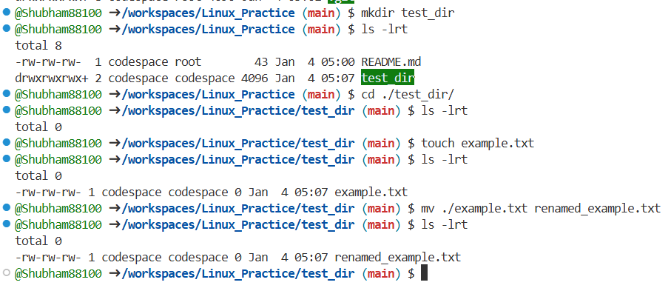
Through command mkdir I have created directory / folder named as test_dir , then inside that directory have created one empty file named as example.txt using touch command & renamed that file as renamed_example.txt using mv command
2. Viewing File Contents
Use cat to display the contents of /etc/passwd.
Display only the first 5 lines of /etc/passwd using head.
Display only the last 5 lines of /etc/passwd using tail.

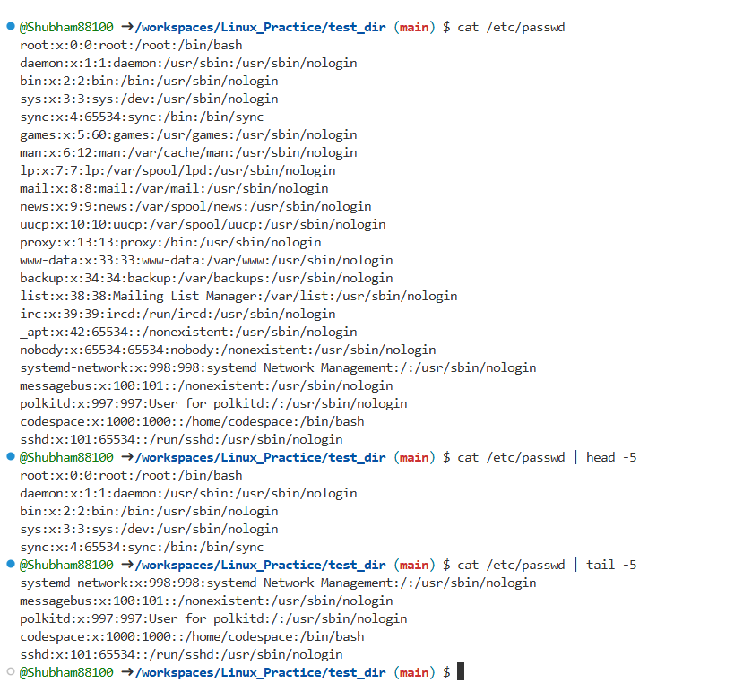
Here I have used cat command to see the content of passwd file present inside /etc directory
Also used head -5 & tail -5 command to see first & last 5 lines of passwd file respectively.

3.Searching for Patterns
Use grep to find all lines containing the word "root" in /etc/passwd.
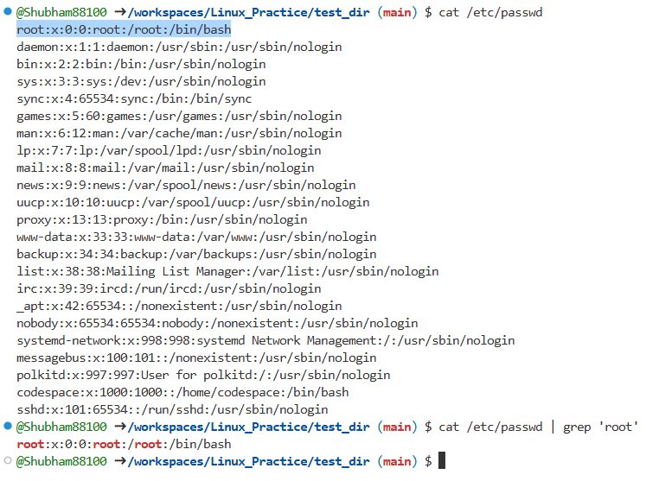
Here I have used grep command to see the lines where word ‘root’ is present.
4. Zipping and Unzipping
Compress the test_dir directory into a file named test_dir.zip using zip.
Unzip test_dir.zip into a new directory named unzipped_dir.
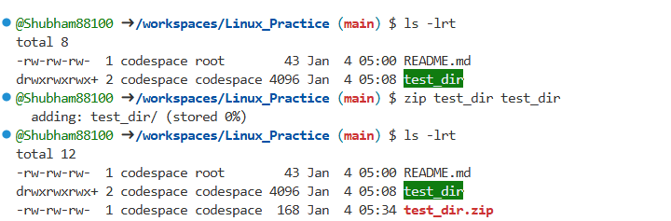
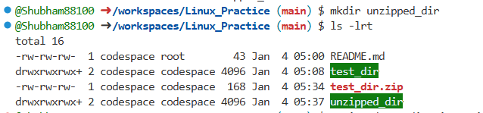
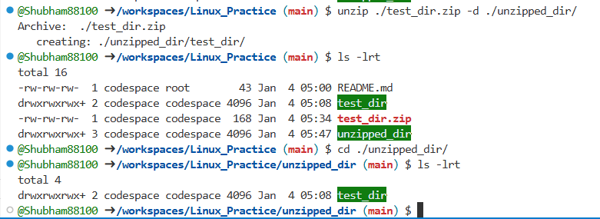
Here First I have compressed the test_dir directory into a zip file named as test_dir.zip using zip command then have created one directory named as unzipped_dir using mkdir command & extracted that test_dir.zip file into this newly created unzipped_dir named directory using unzip command pfa snaps for your reference.

5. Downloading Files
Use wget to download a file from a URL (e.g., https://example.com/sample.txt).

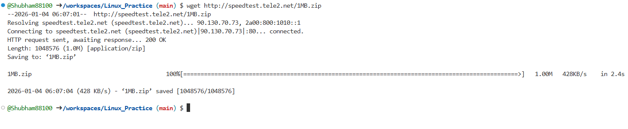
Have used wget command to download one file from http://speedtest.tele2.net/1MB.zip this URL

6. Changing Permissions
Create a file named secure.txt and change its permissions to read-only for everyone using chmod.
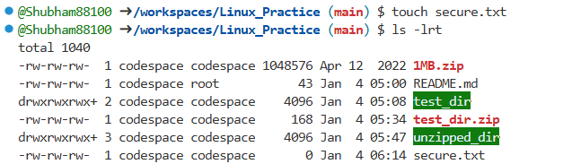
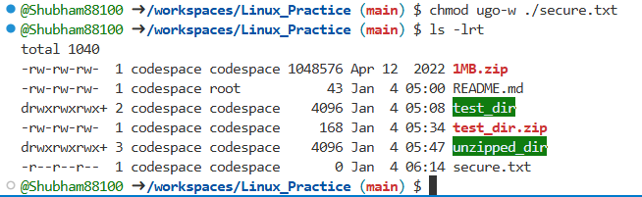
For this question I have created one file named as secure.txt using touch command , file is created with read & write permission to all users so I used chmod ugo-w command to remove write permission from all users & kept read permission as it is.

7. Working with Environment Variables
Use export to set a new environment variable called MY_VAR with the value "Hello, Linux!".
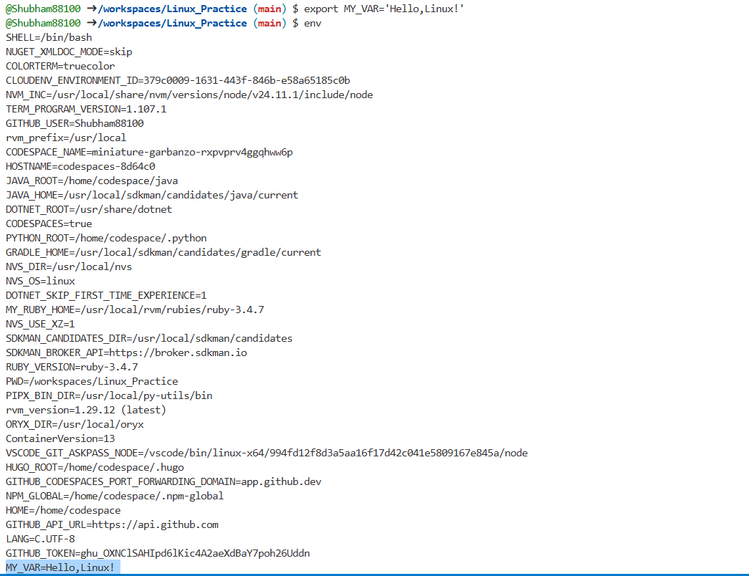

In this I have created one user defined environment variable named as MY_VAR with value ‘Hello,Linux!’ using command export then verified the same through env / printenv & echo $MY_VAR command

Github Repo Link : https://github.com/Shubham88100/Linux_Practice/

Thank you!

